Virtual Vahana 2026 – Phase 1 Technical Report
Project: CARLA ADAS Fusion System
Team Name: NextVolt
Team Members: Karan Rajesh, Vaikunth MS, Tharun Kumaar RK, Mahesh Paul J, Sagar Sewak, Francis Solomon X, Harishankar MN

1. Problem Statement
Urban and highway driving environments demand highly integrated Advanced Driver-Assistance Systems (ADAS) that operate without mode conflicts. Standard simulator implementations often lack production-grade sensor fusion, resulting in "ghost braking" on slopes or erratic steering corrections at high speeds. The objective of this project is to develop a robust, Level 2 assisted driving suite within the CARLA simulator that prioritizes safety over convenience. This requires engineering a deterministic arbitration layer that seamlessly manages Lane Keeping Assist (LKA), Adaptive Cruise Control (ACC), and Autonomous Emergency Braking (AEB) while maintaining absolute driver-in-the-loop awareness through a clear Human-Machine Interface (HMI).

2. System Overview
The ADAS Fusion System is developed entirely in Python, utilizing the CARLA Python API to interface with a simulated vehicle physics engine running at a locked 60 Hz.
- Simulator Framework: CARLA 0.9.11
- Technology Stack: Python 3.12, PyGame (for HMI rendering), NumPy (for matrix and threshold calculations).
- Key Software Classes: World, ADAS (managing ACC and FCW), LKAController, PIDController, RadarSensor, SemanticLidarSensor, and custom HUD rendering classes (including a Tesla-style spatial dashboard).
- Control Paradigm: Keyboard-controllable manual driving overlaid with modular, suppressible ADAS assists.

3. Methodology
Our engineering approach follows a strict Perception $→$ Fusion $→$ Decision $→$ Actuation pipeline.
- Perception & Fusion: Raw sensor data from Radar, Cameras, and Raycast sensors are inherently noisy. We process this data through a custom "Ghost Filter," cross-referencing kinematic distances with Semantic LiDAR and IMU pitch data to eliminate false positives caused by road geometry (e.g., steep slopes).
- Decision & Arbitration: We established a strict hierarchical state machine. Active safety is paramount; therefore, control priority strictly follows: AEB $>$ ACC $>$ LKA $>$ Manual Input.
- HMI Design: To prevent driver distraction, the UI is split between a classic heads-up display and a consolidated right-side telemetry panel, supplementing situational awareness with a top-down spatial mini-map.

4. Algorithms & Calculations

4.1 Autonomous Emergency Braking (AEB) & Forward Collision Warning (FCW)
The AEB system calculates risk using both dynamic Time-To-Collision (TTC) and static kinematic stopping distances (inspired by UNECE R152 and ISO 22737 standards).
Time-To-Collision:
$$TTC=\frac{distance}{max\left(0,-v_{rel}⋅direction\right)}$$
- TTC $≤$ 1.2 s $→$ State 3 (Full Emergency Brake, ~1g deceleration)
- TTC $≤$ 1.8 s $→$ State 2 (Partial Brake, 10% to 45% pressure)
- TTC $≤$ 2.6 s $→$ State 1 (Visual/Audio Warning)
Kinematic Thresholds (based on Ego Speed $v_{mps}$ and reaction time $t_{react}=1.2s$):
$$d_{warn}=v_{mps}⋅1.2+0.5⋅\left(0.35⋅9.8\right)⋅{1.2}^{2}+6.0$$

$$d_{partial}=v_{mps}⋅1.2+\frac{v_{mps}^{2}}{2⋅0.35⋅9.8}+4.0$$

$$d_{full}=v_{mps}⋅0.8+\frac{v_{mps}^{2}}{2⋅9.81}+2.5$$
Persistence & Hold: A threat must persist for 3 consecutive frames before triggering State $≥$ 2. If the vehicle is stopped and an obstacle is detected at $< 3.2m$, a "Standstill Hold" latches the brakes until the driver engages reverse.

4.2 Adaptive Cruise Control (ACC)
Longitudinal speed control utilizes a PID controller with tuned constants: $K_{p}=1.0$, $K_{i}=0.05$, $K_{d}=0.1$.
Safe Following Distance:
$$d_{safe}=\left(\frac{v_{kmh}}{3.6}⋅time_gap\right)+6.0$$
(Default $time_gap = 2.0s$)
Target Velocity Logic:
- No Lead Vehicle: Maintain driver-set cruise speed.
- Lead Detected: Target velocity dynamically adjusts to ego speed plus $2.0⋅\left(lead_dist-d_{safe}\right)$.
- Red Light (No lead): Target velocity smoothly drops to 0.0.

4.3 Lane Keeping Assist (LKA)
The LKA utilizes a MathWorks 4-Stage architecture. To prevent "snap" overcorrections at highway speeds, three stability algorithms are applied per frame:
- Speed-Adaptive Authority: Authority is 100% (0.50 multiplier) at $≤$ 60 km/h, tapering linearly to 56% (0.28 multiplier) at 130 km/h.
- Rate Limiter: Caps maximum steering delta: $max_change=\frac{0.22}{v_{mps}}$
- IIR Smoothing Filter:
$$y\left[n\right]=α⋅x\left[n\right]+\left(1-α\right)⋅y\left[n-1\right]$$
($α$ shifts from 0.55 in city driving to 0.25 on highways $≥$ 100 km/h).
Departure Thresholds: Triggers at $\left|lateral_dev\right|>0.45m$ and clears at$\left|lateral_dev\right|<0.22m$.

5. System Architecture
The system relies on a continuous data loop executing at 60 Hz.
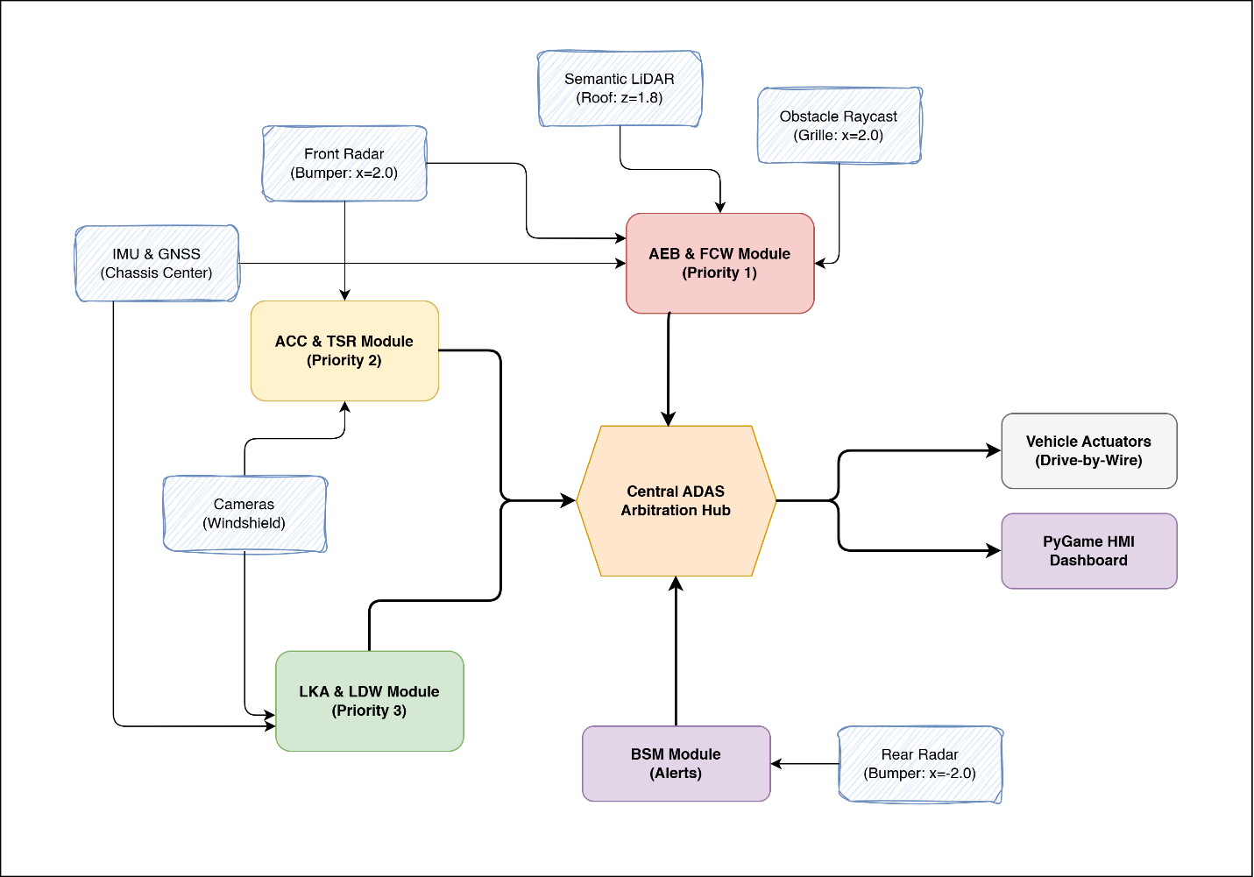
Data Flow Overview:
- Sensors: RGB/Depth/Semantic Cameras, Front Radar (35° FOV), Rear Radar, Semantic LiDAR (64 ch, 50m), Obstacle Raycast, IMU, GNSS.
- Fusion & Decision Layer: Combines Ground-truth smart threat detection with noisy sensor data to feed the AEB state machine, LKA controller, and ACC PID.
- Actuators & Output: Prioritized vehicle control commands (Throttle, Brake, Steer) are dispatched to the CARLA vehicle, while HMI data is sent to the PyGame UI.

6. Results & Observations
Extensive testing within the CARLA environment yielded the following observations:
- AEB Reliability: The system successfully brings the vehicle to a complete halt $< 2m$ from static objects across a testing range of 0 to 130 km/h.
- Longitudinal Control: The ACC holds an exact 2.0s time gap and successfully arbitrates queue-following logic versus smooth red-light stopping.
- Lateral Stability: The LKA's IIR filter and rate limiter resulted in smooth, stable lane centering up to 130 km/h without hazardous oscillation.
- False Positive Reduction: The integration of the Semantic LiDAR and IMU pitch check successfully eliminated all observed false-positive AEB events caused by steep road inclines or curbs.

7. Challenges & Future Scope
Resolved Challenges:
- Radar Ghost Braking: Raw radar on inclines frequently triggered the AEB. Solved via a semantic masking and pitch-check filter.
- LKA High-Speed Instability: PID overcorrection at highway speeds was mitigated through our custom authority taper and IIR smoothing algorithms.
- Traffic Light Conflicts: Solved queue-follow logic by programming the ACC to yield to lead vehicles rather than braking abruptly for the light itself if a queue exists.
Future Enhancements (Phase 2):
- Transition from a PID controller to Model Predictive Control (MPC) for superior longitudinal smoothness.
- Integration of V2X (Vehicle-to-Everything) SPaT/MAP messaging for predictive intersection handling.
- Establishing a ROS2 bridge for potential real-world vehicle hardware testing.

8. Demo Video and Screenshots
Demo Video Gdrive Link

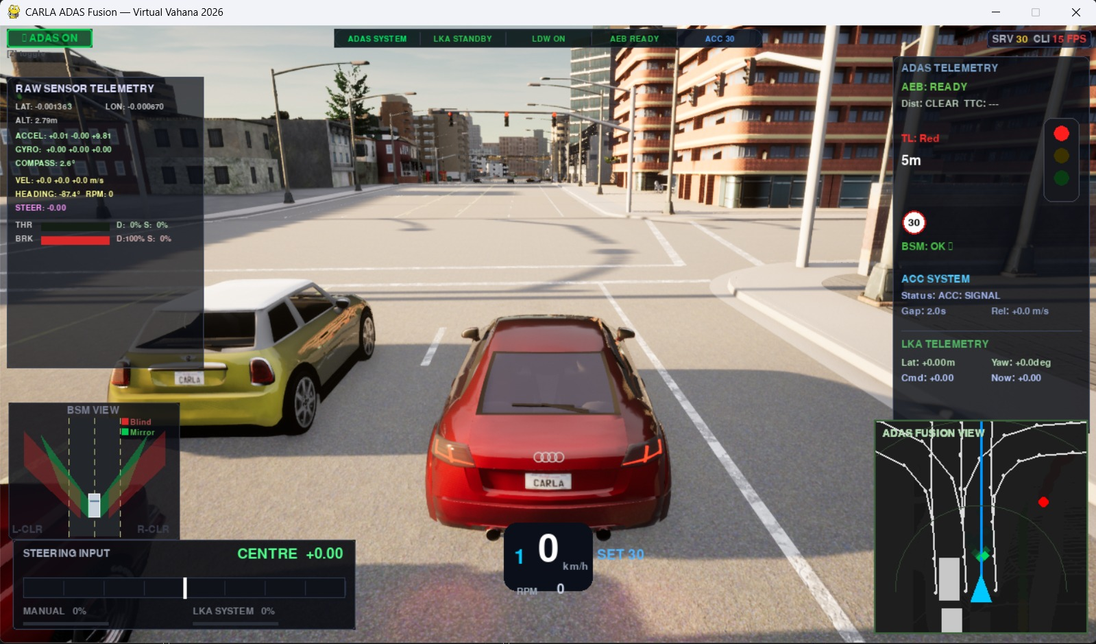
Fig 1: Dashboard HMI Screenshot
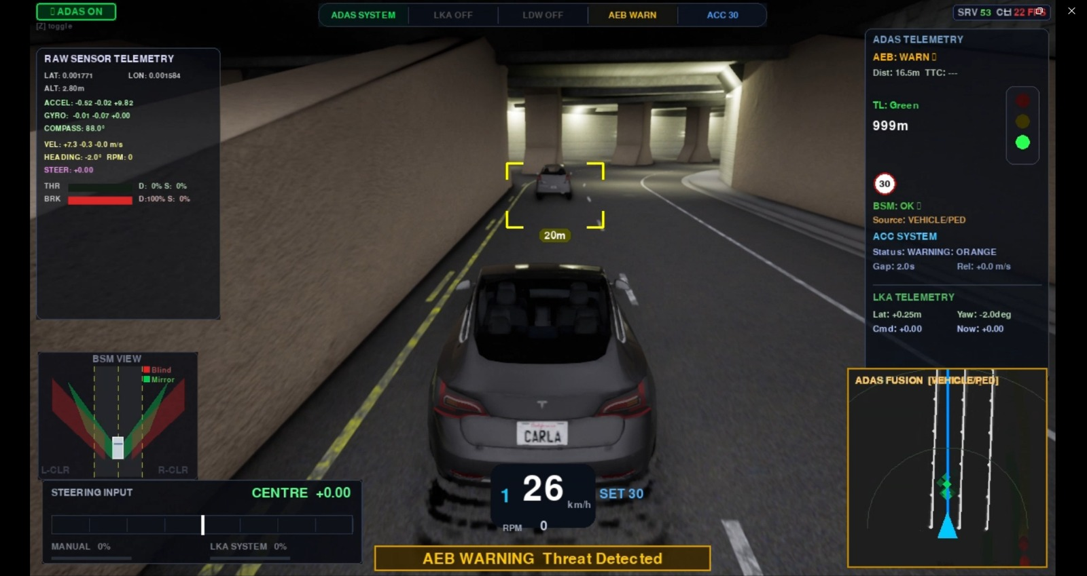
Fig 2: AEB Warning on Dashboard
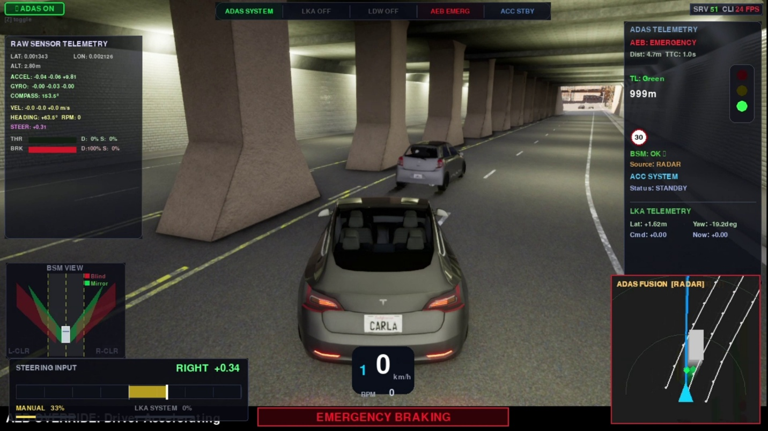
Fig 3: AEB Emergency Breaking
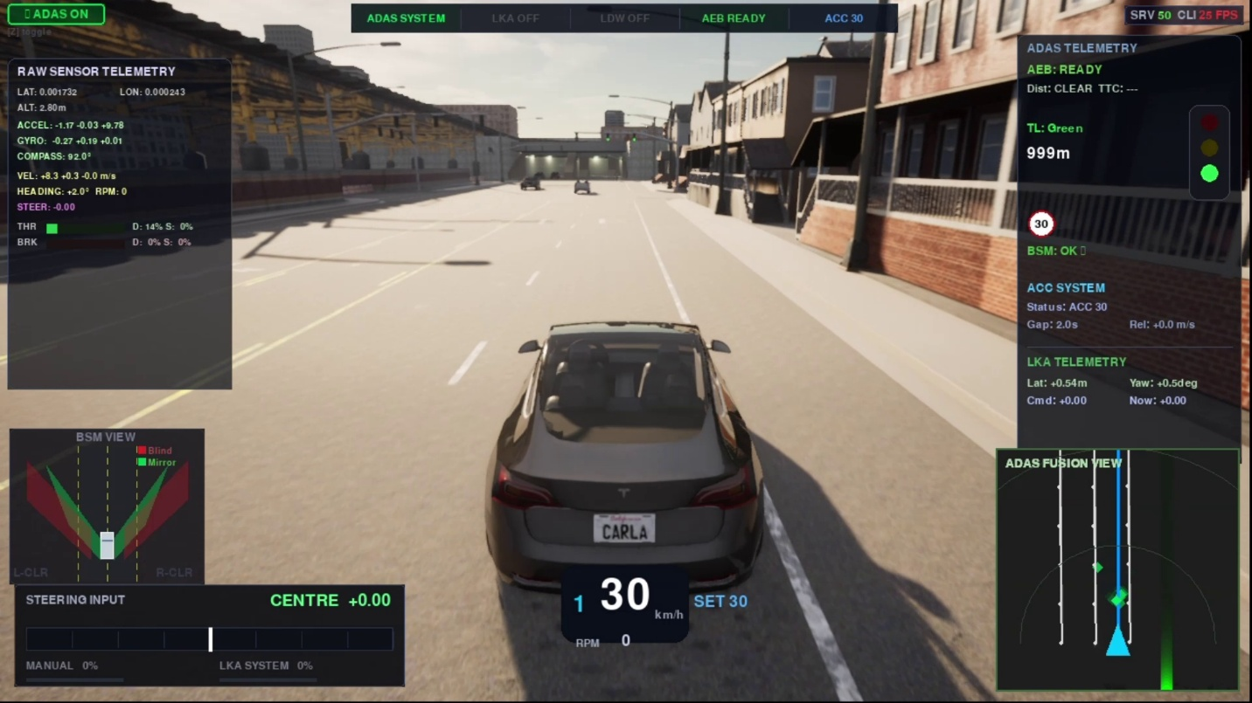
Fig 4: ACC active at 30kmph
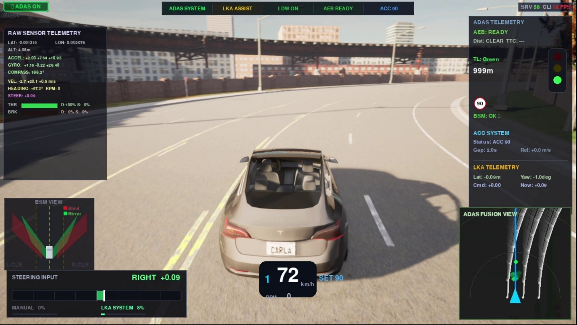
Fig 5: Lane Keeping Assist

